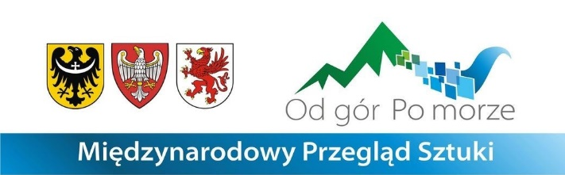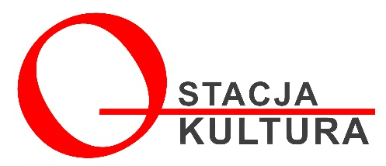

**REGULATIONS OF THE INTERNATIONAL ART REVIEW**

**“FROM THE MOUNTAINS TO THE SEA” 2024**

**I. EXHIBITION ORGANIZER**

Stacja Kultura Association

street Szpitalna 1

78-449 Borne Sulinowo

e-mail. biuro@stacja-kultura.pl

Exhibition commissioners: Jolanta Gramczyńska, prof. Wojciech Bal

Tel.: +48 797 370 360

**II. PURPOSE OF THE EXHIBITION**

The exhibition aims to present artistic diversity, which is also a barometer of our reality. The review is open. It is addressed to all artists regardless of age, artistic achievements, form of artistic expression and creation technique. The presentation of works and direct contact with contemporary art, which will be presented in a historical setting, is to be a fascinating personal experience for both recipients and artists through participation in this event.

With this project, we want to reach the local community, which often does not have the opportunity to experience real art - in this case, visual arts. This is also one of the factors positively influencing the integration process of the inhabitants of this area, because with this project we are creating new traditions that are connected with the history of our region.

**II. RULES OF PARTICIPATION**

a. all people creating art can participate in the review,

b. applications should be sent to the following address: e-mail: biuro@stacja-kultura.pl,

c. the author is obliged to pay the participant's fee in the amount of PLN 120.00 to the organizer's account: 59 1600 1462 1836 8328 7000 0001 BNPPL with the note "OD GÓR PO MORZE" 2024,

d. the exhibition accepts works made in one of the following categories: painting and graphic techniques, photography, sculpture, ceramics, glass

e. the author can send a maximum of 2 works,

f. submitted works should be prepared for presentation (hangers, hooks),

g. application for the exhibition should include: a completed application form, proof of payment, photos of works saved in JPG format with a resolution of min. 300 dpi and min. size 1500 px (shorter side),

h. each file must contain the following information: author's name and surname, title of the work, technique, dimensions, year of execution,

i. each submitted work must contain the following information on the back: name and surname of the author, title of the work, technique, dimensions, year of execution,

j. in the case of spatial forms, the place of the description may be changed,

k. all authors who send works that meet the conditions of the regulations will receive an exhibition catalogue.

**III. ADDITIONAL INFORMATION**

a. by completing the application form, the participant accepts the regulations and consents to making the image of the work available free of charge for marketing purposes, publication in the media for exhibition purposes, which is confirmed by the participant with a handwritten signature on the application form,

b. works sent or delivered to the exhibition should be packed and secured in such a way that they can be returned,

c. the costs of delivering and returning the works and their possible insurance during transport are borne by the author,

d. the works from the exhibition will be returned between August 20, 2024 and August 27, 2024. the works can be collected in person on the same date,

e. the organizer is not responsible for any damage to the works during transport.

**NOTE:** works not corresponding to the above description, without an application form

or proof of payment will not be accepted and included in the exhibition catalogue

**IV. DEADLINES**

a. sending applications by e-mail along with payment confirmation and work files by April 20,2024,

b. send works together with the signed original application by May 10, 2024,

c. duration of the exhibition from May 18, 2024 to June 22, 2024,

d. exhibition opening May 18, 2024 at 4:00 p.m.,

e. exhibition finissage on June 22, 2024 at 4:00 p.m.

**V. FINAL PROVISIONS**

Works prepared for the exhibition should be sent to:

SIEMCZYNO PALACE

Siemczyno 81

78-551 Siemczyno

Gina Malinowski tel. 797 370 360

or

delivered in person to the Siemczyno Palace headquarters

Siemczyno 81,

78-551 SIEMCZYNO

Saturday - Sunday from 11:00 -14:00

On May 10/11, 2024

**PS. HOTEL SIEMCZYNO**

Tel.: 94 375 86 21 / +48 663 746 803