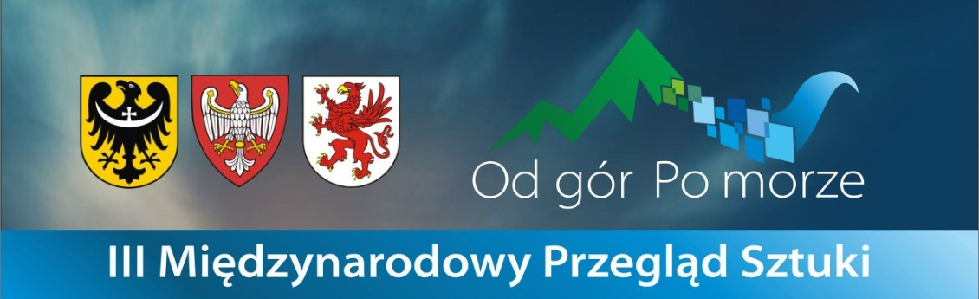

REGULATIONS
I. EXHIBITION ORGANIZER
Association Stacja Kultura
Gina Malinowski
Tel.: +48 797 370 360
ul. Szpitalna 1
78-449 Borne Sulinowo
Email: biuro@stacja-kultura.pl
Exhibition Curator: Jolanta Gramczyńska
II. PURPOSE OF THE EXHIBITION
- Presentation of artistic diversity reflecting the ongoing processes in today's world.
- Enabling the audience to directly engage with contemporary art in the historical setting of the Siemczyno Palace as a unique aesthetic experience.
- Participation of the local community in artistic and cultural activities as a form of integration.
- Building new cultural traditions that enrich the heritage of this region of Poland.
III. RULES FOR PARTICIPATION IN THE EXHIBITION
The exhibition is open to all adult artists, regardless of their artistic achievements or chosen techniques. Due to high interest in the previous year, participation will be granted to artists whose works are selected by the jury.
Participants may submit works in one of the following categories: painting techniques, drawing, graphic techniques (computer graphics, printmaking), photography, sculpture, ceramics, glass, and textile art.
Each artist may submit up to 3 photos of their works. The jury reserves the right to select 1 to 3 works. Participants will be informed about the qualification of their works via announcements on the Stacja Kultura Facebook page, the website www.stacja-kultura.pl, and by email.
After receiving confirmation, each participant must deliver the selected works and pay a participation fee of 120 PLN to the organizer's account:
Stacja Kultura
IBAN: 59 1600 1462 1836 8328 7000 0001
BIC: PPABPLPKXXX
Payment reference: FROM THE MOUNTAINS TO THE SEA 2025
Each file name should include the following information:
- Artist's surname and first name
- Title of the work
- Technique
- Dimensions
- Year of creation
Example of file naming:
Kowalska_Ewa_FOREST_oil_on_canvas_100x80_2020
Each work should be delivered with a clear label on the back, including:
- Surname and first name (or artistic pseudonym)
- Title of the work
- Technique
- Dimensions
- Year of creation
- Works must be ready for hanging/display. Works on paper must be framed with glass.
- The palace interior is not heated. The organizer is not responsible for any damage during the exhibition if the works are not properly secured by the participant.
- All authors whose works meet the requirements will receive an exhibition catalog and their works will be returned after the exhibition closes.
NOTE: Works that do not meet the above criteria, lack a registration form, or proof of payment will not be accepted or included in the exhibition catalog.

IV. JURY MEMBERS:
- Gina Malinowski – Chairperson
- Jolanta Gramczyńska – Exhibition Curator
- Magdalena Wozniak-Melissourgaki – Exhibition Curator
V. DEADLINES:
- By April 10, 2025 – Submission of applications via email with work files.
- By April 30, 2025 – Submission of works with signed registration form and proof of payment.
- May 24, 2025 – August 2, 2025 – Duration of the exhibition.
- May 24, 2025 at 6:00 PM – Opening reception.
- August 2, 2025 at 6:00 PM – Closing event.
VI. ADDITIONAL INFORMATION
a. Submitting works to the exhibition "International Art Review: From the Mountains to the Sea 2025" implies acceptance of these regulations and consent to the publication of personal data according to GDPR policies. The data controller is Stacja Kultura, NIP: 673 190 18 73. The participant also agrees to the free use of images of their works for marketing purposes and media publication related to the exhibition, confirmed by signing the registration form.
b. Works submitted must be packed securely for return shipment.
c. Delivery and return shipping costs, including any insurance, are the responsibility of the artist.
d. The return of works will be completed by September 30, 2025. Works can be collected in person by this date.
e. The organizer is not responsible for any damage to works during transport.

VII. FINAL PROVISIONS
Properly secured works for the exhibition "From the Mountains to the Sea 2025" should be sent to:
PAŁAC SIEMCZYNO
Siemczyno 81
78-551 Siemczyno
Gina Malinowski Tel.: 797 370 360
Email: biuro@stacja-kultura.pl
Alternatively, they can be delivered in person by arranging a delivery date via phone or on April 26/27, 2025 (Saturday/Sunday) between 11:00 AM and 4:00 PM at the Museum of Pomeranian Land, Siemczyno Palace, Siemczyno 81, 78-551 Siemczyno.
We invite you to participate and wish you success in the exhibition!

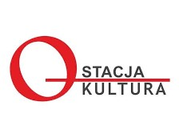

ps.

HOTEL SIEMCZYNO
biuro@palacsiemczyno.pl
Tel.: 94 375 86 21 /
+48 691 283 009

