REGULATIONS OF THE IV INTERNATIONAL ART REVIEW
„FROM THE MOUNTAINS TO THE SEA 2026“

I. ORGANIZER
The IV International Art Review „From the Mountains to the Sea 2026“ is organized by
Stacja Kultura Association, registered at ul. Szpitalna 1, 78-449 Borne Sulinowo, Poland (KRS, NIP: 673 190 18 73, REGON: 366254910; hereinafter: „Organizer“).
President: Gina Malinowski
Contact: Tel. +48 797 370 360, E-Mail: biuro@stacja-kultura.pl

II. OBJECTIVES
- Presentation and promotion of Polish and international artistic works in visual arts, including: Painting, sculpture, drawing, printmaking, installation, eco-art, performance, photography, ceramics, textile art, scenography, digital art, industrial design, stained glass (incl. 3D structures).
- Fostering international collaboration and exchange among artists.
- Access to contemporary art in regions distant from major cultural hubs.
- Community integration through participation in artistic activities.
- Bridging past and present by exhibiting in the historic Palace of Siemczyno.
- Establishing new humanistic traditions to enrich the cultural heritage of West Pomerania.

III. AWARDS
The cyclically organized Art Review enjoys growing international recognition. To honor artistic achievement, the Organizer awards:
- Grand Prix – Marszałek of West Pomerania Award (cash prize),
- Stacja Kultura Association Award,
- „Discovery of the IV Art Review 2026“.
The Jury decides based on artistic value, originality, and execution quality. It reserves the right to withhold awards, adjust their number, or redistribute them.

IV. JURY COMPOSITION
The Organizer appoints a five-member Jury:
- Chair: Gina Malinowski,
- Members: Prof. Robert Bartel, Prof. [Name missing], Magdalena Woźniak-Melissourgaki,
- Curator: Jolanta Gramczyńska.
Selection Process:
- Preliminary selection based on digital reproductions,
- Final selection based on original works.
The Jury may revise decisions if originals fail to meet expectations.

V. PARTICIPATION RULES
- Open to all artists (adults, regardless of background).
- Eligible works: Created 2023–2026 in listed techniques.
- Submission: Up to 3 digital files to biuro@stacja-kultura.pl.
- Fee: 120 PLN (after qualification) to: IBAN: 59 1600 1462 1836 8328 7000 0001, BIC: PPABPLPKXXX, Reference: „IV Art Review 2026“.
- File naming: Must include: Name, title, technique, dimensions, year, price (incl. 10% commission for the Organizer). Example: Kowalska_Ewa_Forest_Oil_on_Canvas_100x80_2024_1500EUR
- Presentation: Works must be exhibition-ready (framed, with installation instructions for complex pieces).
- Labeling: Each work must include on the reverse: Name, title, technique, dimensions, year, contact, price.
- Catalog: Qualified artists receive a post-exhibition catalog.
- Liability: The Organizer is not liable for damage to inadequately secured works or during transport.

VI. DEADLINES
- Digital submissions: By March 21, 2026,
- Physical submissions: By April 30, 2026,
- Opening (Vernissage): May 23, 2026, 6:00 PM,
- Closing (Finissage): August 8, 2026, 6:00 PM,
- Exhibition duration: May 23 – August 8, 2026.

VII. FINAL PROVISIONS
- The works qualified for the 4th Art Review 2026 must be sent by the participant at their own expense and collected in person or, likewise at their own expense, by arranging and paying for a courier service.
- It is possible to deliver the works in person (on April 26/27, 2026, Saturday/Sunday, between 11:00 a.m. and 4:00 p.m.) to the headquarters of the Museum of the Pomeranian Region, Siemczyno Palace (Siemczyno 81), and to collect them (from August 30, 2026) after prior telephone arrangement of the date.
- The works must have return packaging, be properly secured, and adequately prepared for transport. Marked with “4th Art Review 2026” and accompanied by the signed original application form and proof of payment, they must be sent by April 30, 2026, at the participant’s own expense to the following address:
Pałac Siemczyno
Siemczyno 81
78-551 Siemczyno

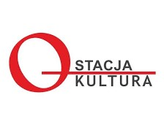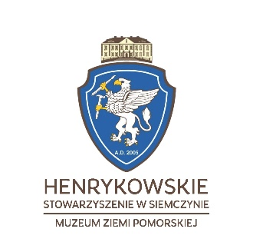

Accommodation is available at Palace Siemczyno :

Hotel Siemczyno
Siemczyno 81
78-551 Siemczyno
biuro@palacsiemczyno.pl
Tel.: +48 94 375 86 21
+48 691 283 009

